**LAB MANUAL**

**NAME: ABDUL SALAM**

**ROLL NO: BIT-24S-012**

**COURSE: ARTIFICIAL INTELLIGENCE (AI)**

**COURSE INS: MA’AM AQSA UMAR**

**LAB NO: 1**

**INTRODUCTION TO PYTHON :**

**Python is an easy-to-learn programming language that lets you write code quickly and clearly. It’s used for building websites, analyzing data, creating AI and machine learning models, automating tasks, and much more.**

TASK NO 1: Make 2-2 programs of each datatype**.**

1. **NUMERIC TYPES**

**Integer (int)**

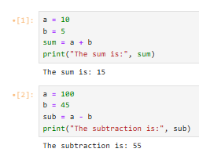



**Floating-point (float)**

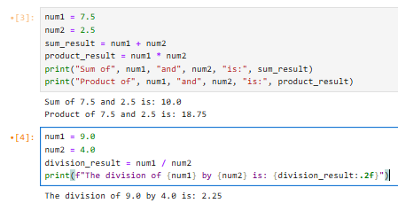

**Complex (complex)**

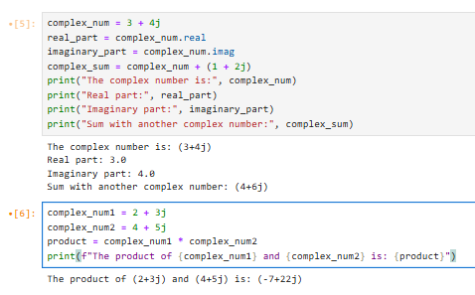

1. **Sequence Types**

**String (str)**

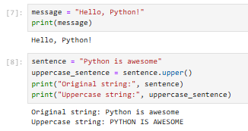

**List (list)**

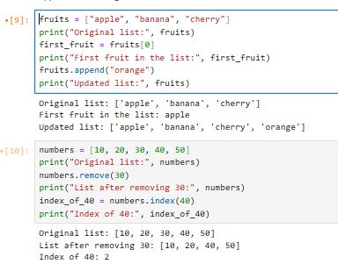

**Tuple (tuple)**

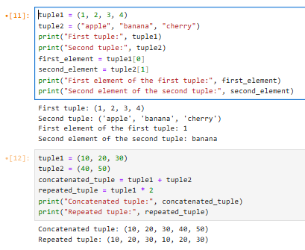

**Range (range)**

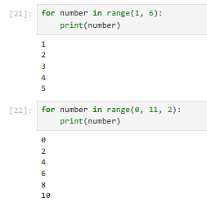

**3. SET TYPES**

**Set (set)**

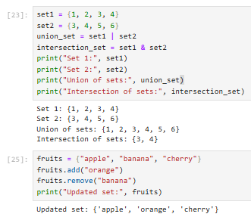

**Frozen Set (frozenset)**

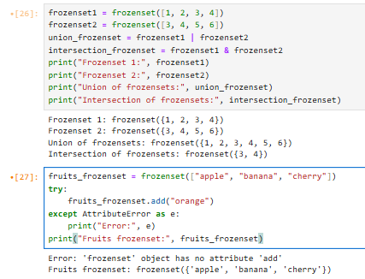

1. **MAPPING TYPE**

**Dictionary (dict)**

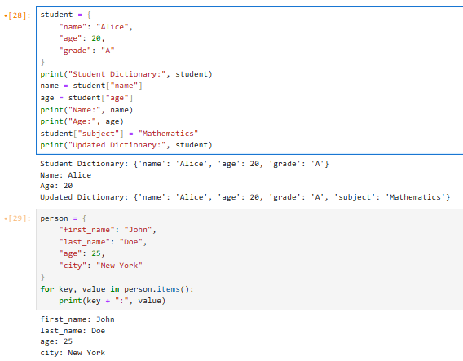

1. **Boolean Type**

**Boolean (bool)**

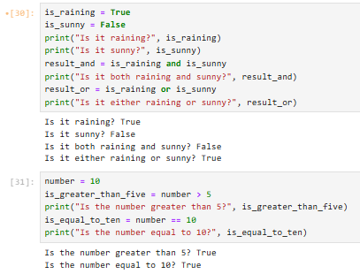

**TASK NO 2: Make up to 5 Shape programs using *.**

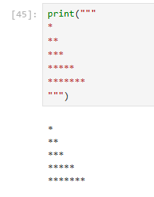

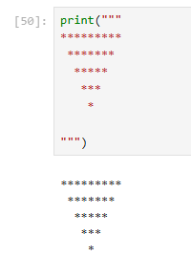

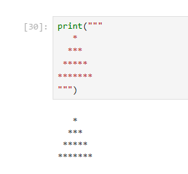

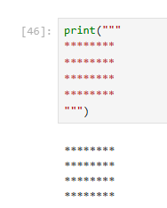

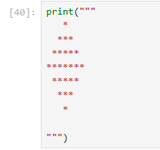

# TASK NO 3: Make same shapes you have made in task 2, using * mutiple by number.

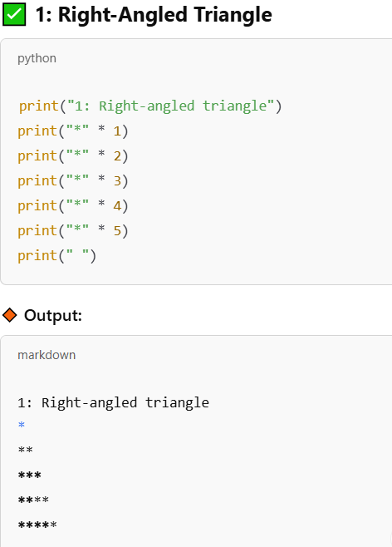

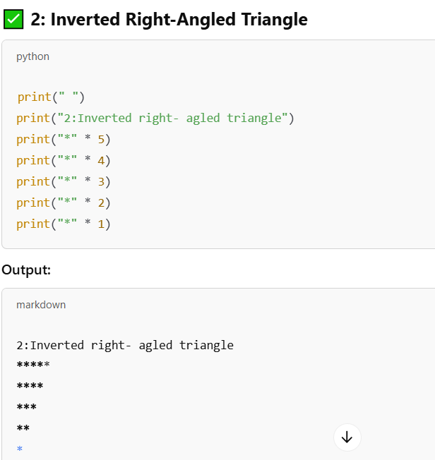

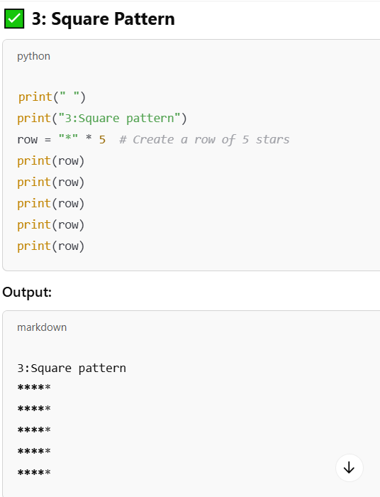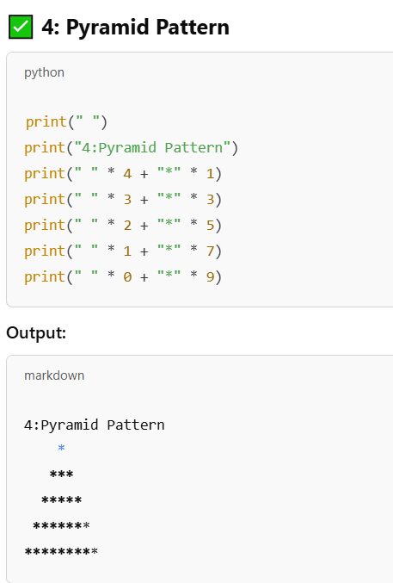

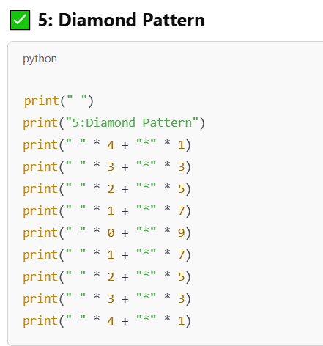

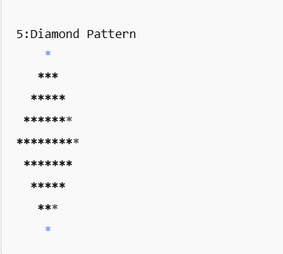

## LAB 02

## Python Looping Tasks

1. **Print numbers from 1 to 10 using a for loop.**

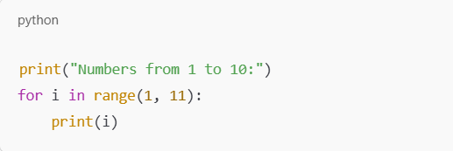

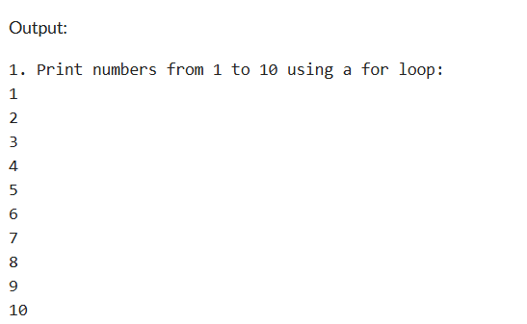

**2.Print all even numbers between 1 and 20 using a while loop.**

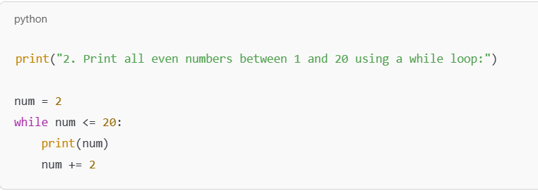

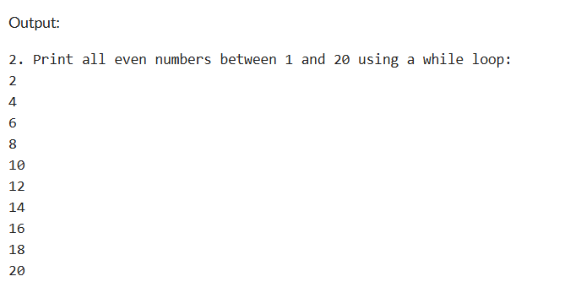

1. **Calculate the sum of numbers from 1 to 100 using a loop.**

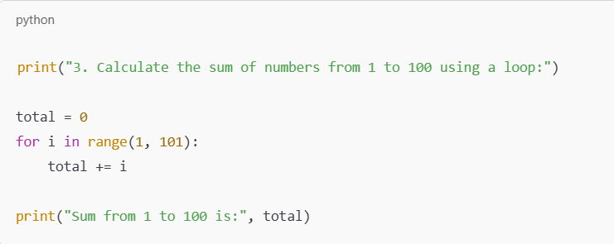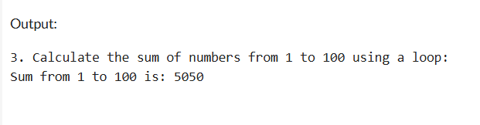

1. **Print the multiplication table of 5 using a loop.**

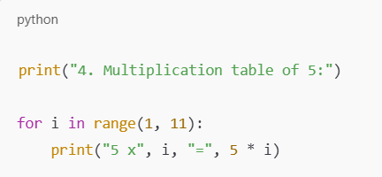

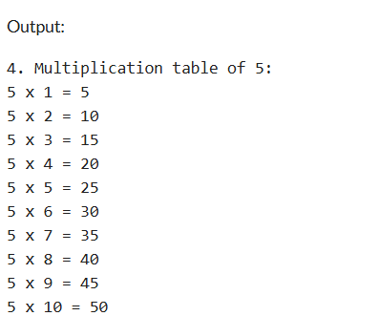

1. **Find the factorial of a given number using a for loop.**

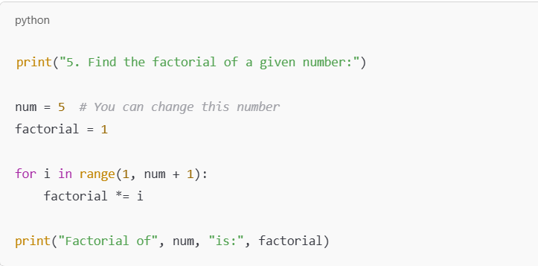

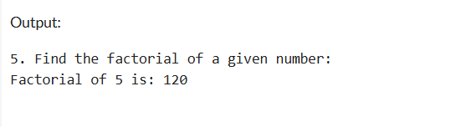

1. **Iterate over a list of fruits and print each item.**

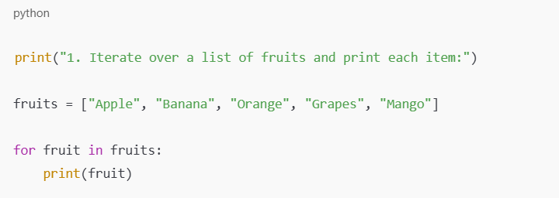

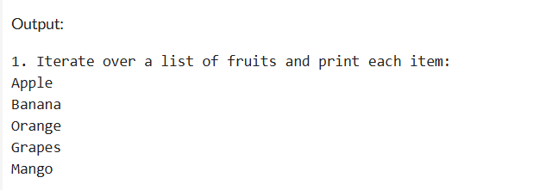

1. **Create a list of numbers and print only the odd numbers using a loop.**

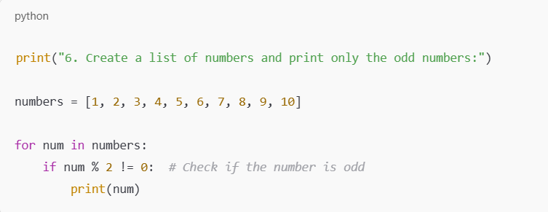

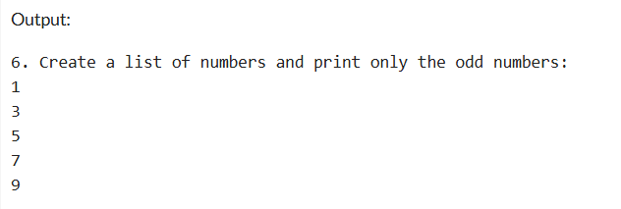

**LAB 03**

**LAB 04**

# Tasks Related to Arithmetic Operators

1. Write a Python program to take two numbers as input and perform all arithmetic operations on them.

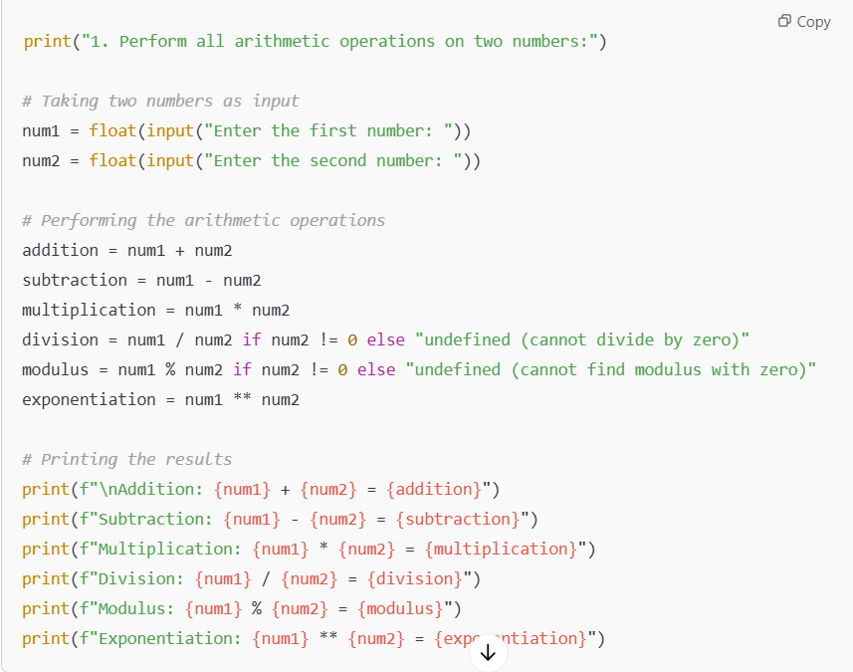

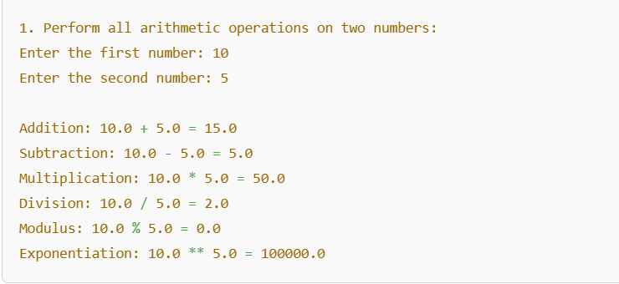

1. Create a function that takes two numbers and returns their sum, difference, product, and quotient.

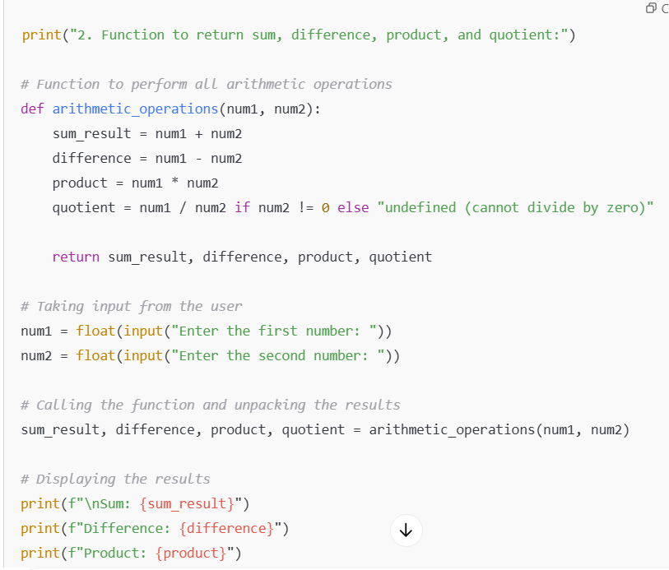

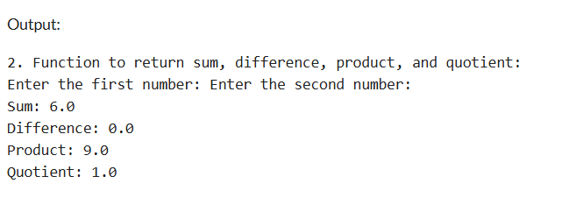

1. Write a Python script to find the remainder when one number is divided by another.

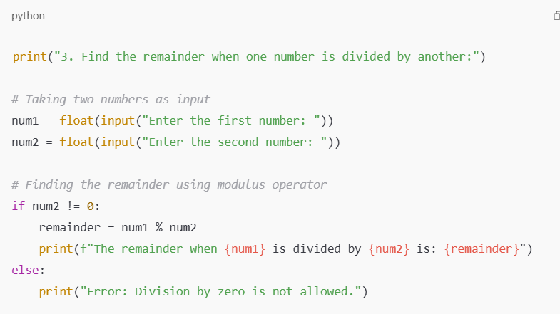

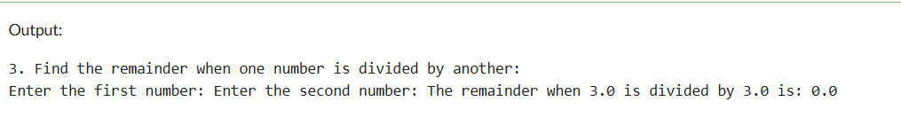

1. Write a program to calculate the area of a circle using the formula: Area = π * r^2.

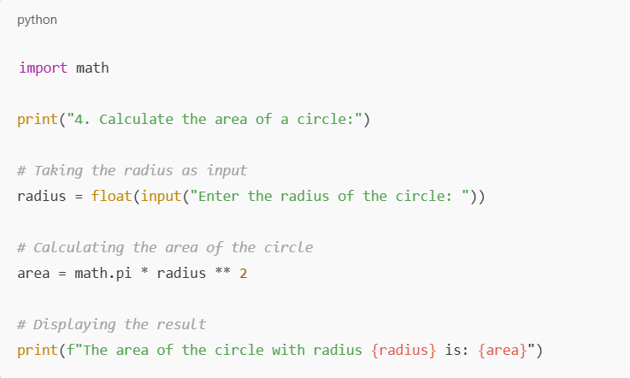

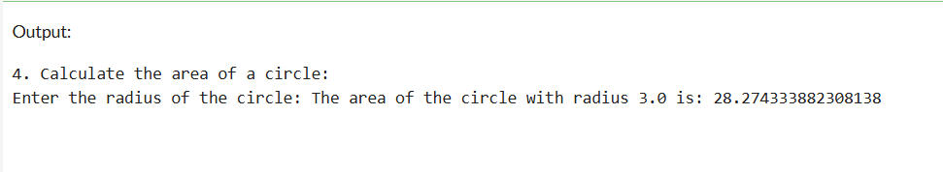

1. Implement a program that takes a number as input and returns its square and cube using exponentiation.

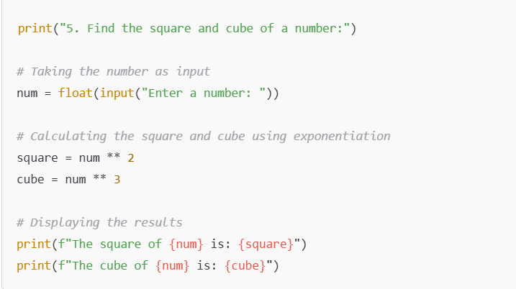

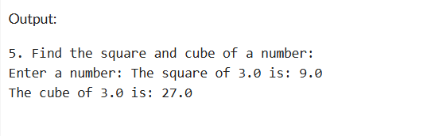

1. Create a simple calculator in Python that allows the user to choose an operation (addition, subtraction, etc.) and inputs two numbers.

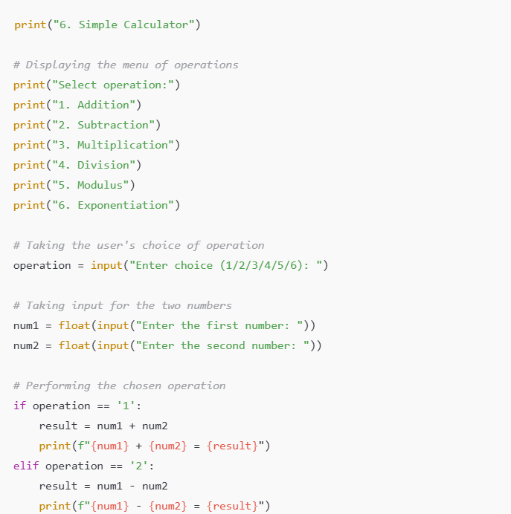

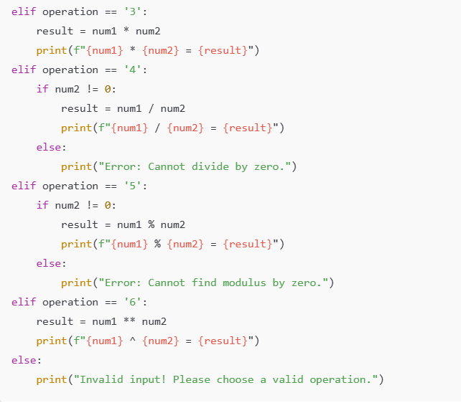

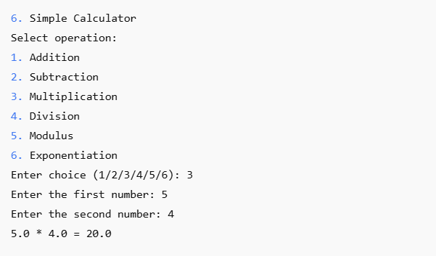

# LAB 05

# Python if and else Statements

1. **Basic Task:** Write a program that checks if a given number is positive, negative, or zero.

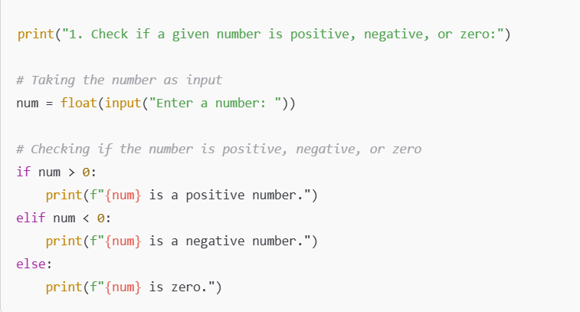

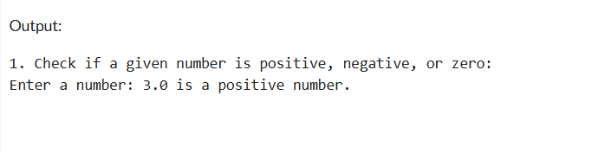

1. **Intermediate Task:** Write a program that takes user input and determines whether it's a even or odd.

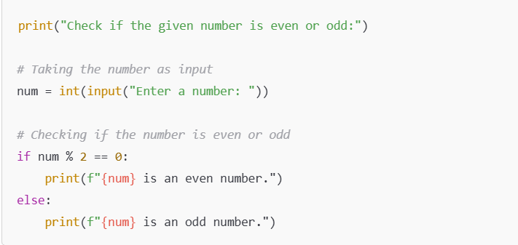

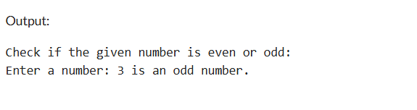

1. **Advanced Task:** Create a program that asks user to print:
   * "Excellent" if marks are above 80
   * "Good" if marks are between 60 and 80
   * "Needs Improvement" if marks are below 60

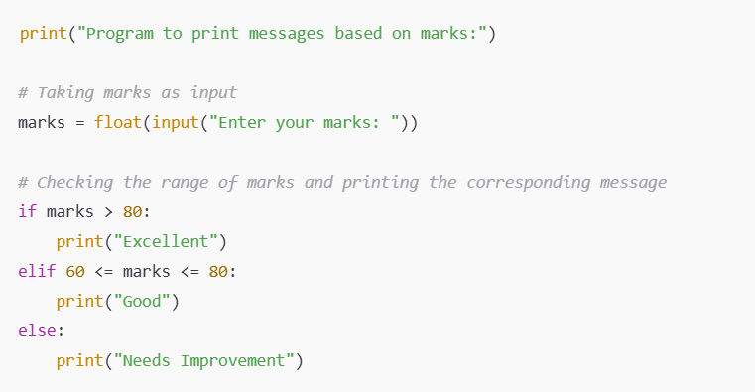

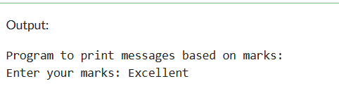

**LAB 06**

# Python for and while Loops

1. **Basic Task:** Write a for loop to print the first 10 natural numbers.

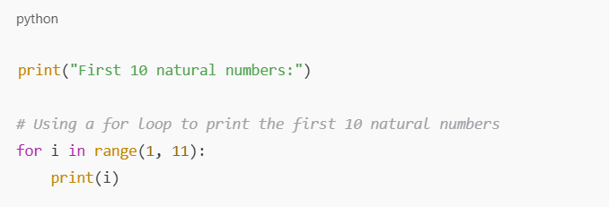

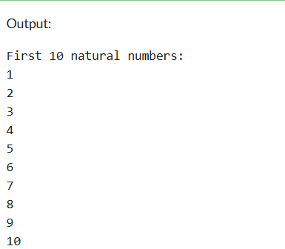

1. **Intermediate Task:** Write a while loop that prints numbers from 10 down to 1.

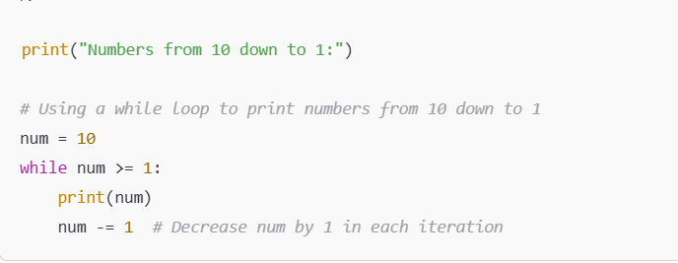

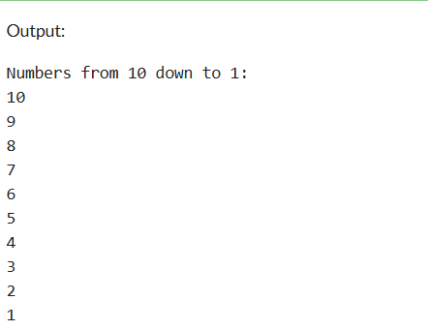

1. **Advanced Task:** Create a program that uses a for loop to iterate over a string and count the number of vowels.

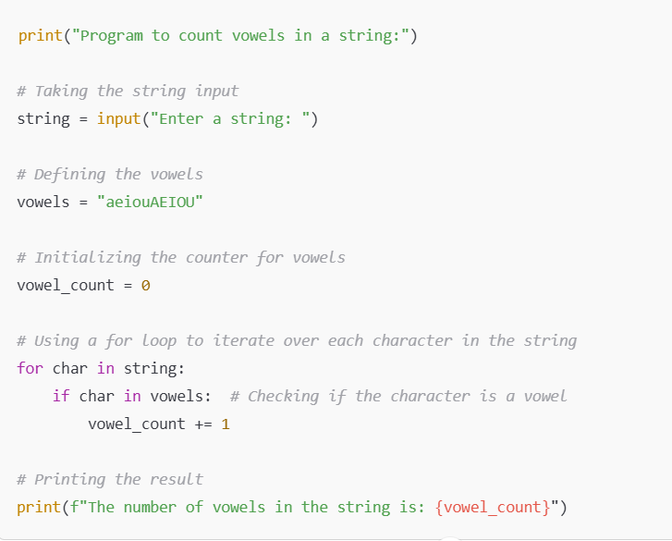

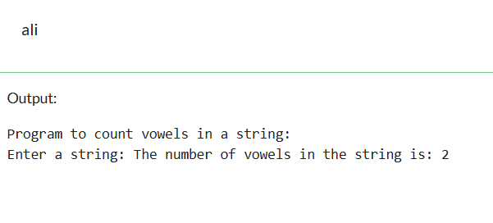

1. **Challenge Task:** Write a program that prints the Fibonacci series up to n terms using a while loop.

